FIRST TERMINAL EXAMINATION – SEPTEMBER2019
MATHEMATICS

Class: III Max Marks: 60
Date:20.09.19 Time: 3 hours
I. Fill in the blanks: (5 × 1= 5)
1) The place value of 9 in 9365 is ___________.
2) The smallest 4-digit number is __________.
3) The ordinal number for 3 is ________.
4) 5369 + 0 = ______
5) The number after 879 is ______
II. Choose the correct answer: (5 × 1= 5)
6) The sum of 501 and 41 is _____
(a) 541 (b) 542 (c) 543 (d) 544
7) Which of the following is the list of odd numbers?
(a) 234,145,146,254 (b) 200,203,206,209
(c) 915,917,919,923 (d) 192,194,198,199
8) Eight thousand and ninety is ______.
(a) 8009 (b) 8900 (c) 8019 (d) 8090
9) The predecessor of 5999 is ______
(a) 5998 (b) 6000 (c) 5990 (d) 6010
10) The number between 3249 and 3251 is _______
(a) 3205 (b) 3250 (c) 3240 (d) 3204

III. Match the following: (5x1=5)
11) 2311 + 1243 (a) 561
12) Odd number (b) 10
13) 53 (c) 3554
14) 5 X 2 (d) 14
15) 86 – 72 (e) fifty-third
IV. Write whether the following statements are TRUE or FALSE: (5 × 1= 5)
16) The successor of an even number is an even number. ____________
17) The cardinal number for thirteenth is 30._____________
18) 3656 + 1 = 3657. ____________
19) The largest 3-digit number is 100. ____________
20) The next even number after 5220 is 5222. ____________
V. Answer the following: (10 × 2= 20)
21) Write the predecessor and successor
_______, 6660, _______
22) Write the place value of 5 in the given numbers
(a) 2354 ___________
(b) 5627 ___________
23) Write the cardinal number of the following
(a) Sixty-seventh ____________
(b) Fiftieth ____________

24) Complete the following
(a) 3968 + = 5642 + 3968
(b) 425 + (1698 + 1111) = (425 +1698) +
25) Write the number names of the following:
(a) 9364 - ___________________________________________
(b) 3049 - ___________________________________________
26) Circle the bigger number
(a) 6456, 4585
(b) 3564, 5645
27) Write the numbers for the given number names
(a) Nine thousand one hundred two - ________
(b) Eight thousand four hundred twenty seven - ________
T | O
6 | 7
2 | 9
28) Add:

________________
________________
29) Subtract:
T | O
7 | 6
1 | 7
________________
________________

30) Expand:
1689= + + +
VI. Answer the following: (5×3= 15)
31) Add:
Th | H | T | O
1 | 3 | 6 | 5
2 | 7 | 8 | 4
___________________
___________________
32) Write the ordinal numbers for the following
(a) 34- _____________________
(b) 19 – ____________________
(c) 56 - ____________________
33) Write the number shown on the abacus.
Number

Th | H | T | O
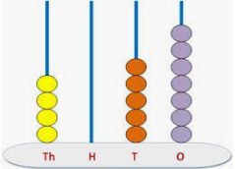

34) (a) Write the following numbers in ascending order:
4296, 4649, 4825, 4572
_______________________________________
(b) Write the following numbers in descending order: 5267,5343,3540,5677
_______________________________________
35) Make the largest and smallest 4-digit numbers using the following digits.
Smallest
Largest

- 6, 5, 9, 7

- 2, 0, 1, 8
VII. Answer the following: (5)
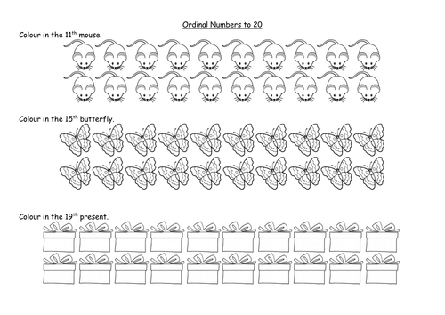
36) Colour as directed
(a)

(b)
